National Rural Health Association’s In-District Advocacy Toolkit

Now more than ever, it is important for Congress to hear your voice. Change starts with uplifting you and your community’s stories. Your advocacy is essential to drive change and support the rural health infrastructure and workforce, and improve rural health outcomes.

The National Rural Health Association created an in-district toolkit to help guide your advocacy and engage your Members of Congress at the state and district level.

Table of Contents

2026 Congressional Schedules 1
Find Your Members of Congress 1
Committee Assignments 2
Identify District-Level Congressional Events 3
Engaging with Your Members of Congress 3
Schedule a Meeting 3
Email Template(s): 3
General Meeting Introduction 3
Hosting Introduction 4
Thank You/ Follow Up 4
Meeting Tips 4
Social Media Engagement 5
Talking Points 6
NRHA Advocacy Materials 6
Additional Resources 6

2026 Congressional Schedules
Although advocacy is year-round, Congress has periods of time known as in-district working periods, or congressional recess. During these periods, Members return to their home states and districts, which allows constituents the opportunity to engage with their members at home. You can meet with your member of Congress or their staff in-district or host them at your facility. These are both great ways to build your relationship and highlight the realities of rural healthcare on the ground.
2026 House Schedule
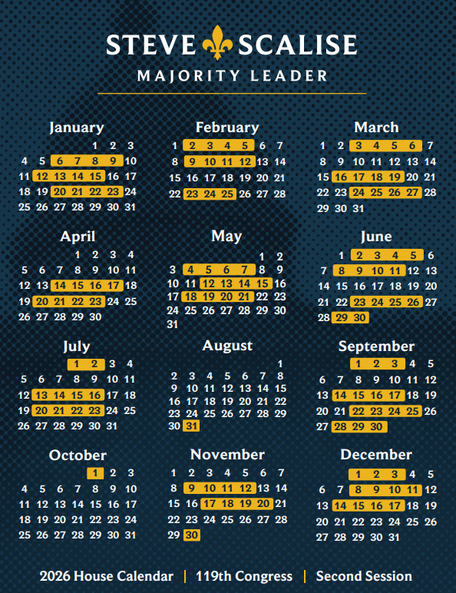

2026 Senate Schedule
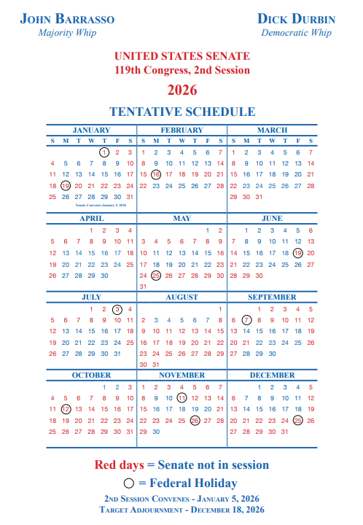

Find Your Members of Congress
Quickly identify and contact elected officials representing your rural community through the following resources:

- You can identify your Representative on the U.S. House site. You have 1 representative who represents your congressional district.
- You can identify your Senators on the U.S. Senate site. You have 2 senators that represent your entire state.

Committee Assignments
Members of Congress also serve on committees of jurisdiction that focus on certain policy and issue areas. Knowing which committees your designated members serve on can help you target your advocacy efforts.

You can view the current Senate Committee Assignments here and the current House Committee Assignments here.

Committees that have jurisdiction over rural health related areas include:

House of Representatives | Senate
Ways and Means Committee  Jurisdiction over the Medicare Program. | Finance Committee  Jurisdiction over the Medicare and Medicaid programs and the Affordable Care Act.
Energy and Commerce Committee  Jurisdiction over the health sector broadly including the Affordable Care Act, Medicaid, mental health, health IT, 340B, and HRSA programs. | Health, Education, Labor, and Pensions (HELP) Committee  Jurisdiction over the majority of HHS, including HRSA programs.
Agriculture Committee  Jurisdiction over the Farm Bill and USDA. | Agriculture Committee  Jurisdiction over the Farm Bill and USDA.
Appropriations Committee  Jurisdiction over the federal government’s discretionary budget. | Appropriations Committee  Jurisdiction over the federal government’s discretionary budget.
Veterans’ Affairs Committee  Jurisdiction over medical care for veterans. | Veterans’ Affairs Committee  Jurisdiction over medical care for veterans.
Education and Workforce Committee  Jurisdiction over education and workforce programs. | Special Committee on Aging  Has no legislative authority but can study issues and conduct oversight of programs related to Older Americans.

Identify District-Level Congressional Events
When members of Congress are on recess, they often host a variety of events that constituents are encouraged to attend. Events such as town halls or open forums are excellent avenues to voice your opinions and let your issues be known by your Member of Congress.

To find out when town hall meetings or other open events are being held in your Congressional district, monitor your lawmaker’s websites and social media accounts, sign up for email alerts, or periodically call their district office for event updates.

Engaging with Your Members of Congress

Schedule a Meeting
During in-district periods, you can request a meeting with your members of Congress or their district staff. Additionally, you can host your members of Congress and their staff at your local health facility.

To do so, call or email your Representative or Senator’s district office to request a meeting. When requesting a meeting, try to contact the in-district scheduler or staff lead who can schedule your meeting or forward your request to the correct person. Contact information for district offices can be found on their official website online.

Please send any applicable media materials or pictures and a summary of the visit to NRHA’s Grassroots & Communications Coordinator, Sabrina Ho (sho@ruralhealth.us).

Email Template(s):

General Meeting Introduction
Subject: Constituent In-district Meeting Request on [DATE HERE] with Rep./Sen. [CONGRESS MEMBER NAME]

Hello [STAFFER/SCHEDULER],

My name is [YOUR NAME] and I am a constituent from [TOWN, STATE]. I am writing to request an in-district meeting with Rep./Sen.[CONGRESS MEMBER NAME] during [TIME FRAME YOU WANT THE VISIT TO BE]. I am the [TITLE] of [ORGANIZATION] in [STATE] and would like to meet with the Congressman/woman to discuss [TOPIC YOU WOULD LIKE TO DISCUSS ABOUT RURAL]. Please let me know if your office would have any availability to meet during [MONTH] Recess in-district.

Sincerely,
[YOUR NAME]
[TITLE]
[ORGANIZATION]

Hosting Introduction
Dear [STAFFER NAME]
On behalf of [INSERT NAME OF FACILITY/PROGRAM] in [INSERT CITY/TOWN], I would like to invite [SENATOR/REPRESENTATIVE] [LAST NAME] to tour [PROGRAM/FACILITY NAME] during the upcoming [MONTH] recess.
We would like to share with you the services our program/facility has provided our rural community. During your visit we welcome you to [tour the facility, meet our staff, talk to patients, see how our team operates, etc.]. Health care in rural America is critical to a community’s overall well-being. Rural hospitals and facilities comprise as much as 20% of the rural economy, and we look forward to the opportunity to show you the role our work plays in the growth and future of our community here in [INSERT CITY/TOWN].
[INSERT short paragraph about the facility or program—what you do, job numbers, economic footprint, patients cared for, explain your role in providing care.]
We are happy to work with your team to find a date that works well for [SENATOR/REPRESENTATIVE NAME].
All of us at [INSERT NAME OF FACILITY/PROGRAM] look forward to offering a more personal look at the challenges and opportunities in providing health care in rural America through our community.
Sincerely,
[YOUR NAME]
[TITLE]
[ORGANIZATION NAME]
[ORGANIZATION ADDRESS]

Thank You/ Follow Up
Subject: Thank You - Constituent In-district Meeting [DATE] with Rep./Sen. [CONGRESS MEMBER NAME]

Hello [STAFFER/SCHEDULER],

My name is [YOUR NAME] and I am a constituent from [TOWN,STATE]. Thank you for meeting with [YOUR ORGANIZATION] on [DATE] to talk about [TOPICS DISCUSSED]. We appreciate your efforts in supporting rural health in [YOUR STATE]. Please find [any materials or resources needed for follow-up] attached as we discussed in our meeting. I look forward to continuing our relationship with your office and serving as a resource on rural health for your team. If you have any additional questions, please feel free to contact me at [YOUR EMAIL].

Sincerely,
[YOUR NAME]
[YOUR TITLE]
[YOUR ORGANIZATION]

Meeting Tips
Tips for a successful in-district meeting with your Member of Congress or their designated staffer:
- When emailing the member to request a meeting, include any relevant materials so they have a chance to review them before your meeting.
- Since you are focusing on healthcare issues, find out who covers healthcare in their home state or district office.
- During the meeting, thank them for any positive actions that they’ve taken, share your personal story related to the issue, and make a clear request.
- Use the talking points and resources provided in this toolkit to guide your conversation, direct attention to necessary issues/asks, and provide actionable requests for the next steps the member or staff can make.
- Tell a story.
- Follow up after the meeting. Be sure to get their email address and follow up with them via email. Thank the staffer or Member of Congress for their time. Include a reiteration of any key points mentioned, any follow-up material, and any questions you had.

For more information on best advocacy practices and other tips, please find NRHA’s advocacy 101 guide here.

Social Media Engagement
Social media is a great method to further amplify your needs and share your message to others. Constituents should take pictures during in-district events and meetings including a picture with your Member of Congress after meeting with them! Most members of Congress have public facing accounts on social media platforms that allow them to directly communicate with constituents. To find out what platforms your lawmakers use, we recommend you check your member’s website.

When posting, tag your lawmaker and thank them for meeting with you or reiterate your request/ask of them to support certain issues you discussed.

Some template posts can be used as inspiration below:
- Thank you [@SENATOR OR REP] for meeting with [ORGANIZATION] to discuss [SHORT TOPIC THAT WAS DISCUSSED]. We appreciate all you do for #ruralhealth! @NRHA_Advocacy

Don’t forget to tag @NRHA_Advocacy on Twitter and Instagram so we can repost and share!

Talking Points
Please find NRHA’s talking points here:
- NRHA 2026 Rural Health Advocacy Asks Talking Points

NRHA Advocacy Materials
NRHA has an array of leave-behind materials that can help members of Congress and their staff understand important rural health policies and related legislation. You can bring these materials to meetings to guide discussions and leave with staff or share via email as follow up material. All NRHA advocacy leave behind materials can be found on our website under “Advocacy Priority Areas.” Materials include:
- NRHA core leave-behinds
- NRHA topic-specific leave-behinds
- NRHA fact sheets
- NRHA bill-specific leave-behinds

Additional Resources
State-level resources:
- Rural Health Data by State & Congressional District
- State Hospital Closure and Vulnerability Data
- State-Level Medicaid Data
- 2025 Federal Office of Rural Health Policy Funding Data by State

